Westminster Confession Analysis & Pastoral Interview
Omnibus III

Purpose
- To discuss, with a pastor, the role of confessions in the historical church, the modern church, and in the lives of individual believers as well as specific doctrines of interest to you and your classmates.
- To familiarize yourself with your church’s statement and/or confession of faith.
- To give you the opportunity to put your findings in writing and present them to your classmates in an informative, yet casual discussion environment.

Assignment
Statement of Faith Assessment & Comparison - Compare the content of your church’s statement of faith (SOF)/doctrinal statement to the Westminster Confession
  - Are the same topics covered? (ex: nature of God, man, sacraments, etc.)
  - Doctrinal differences: Note at least 2 differences between your church’s position and the Westminster confession (you will discuss these with your pastor – so make sure to do so before your interview!)

Pastoral Interview – Ask the two sets of questions below (General and Specific Theological Topics), making sure to provide with the following:
- The background of your study – why are you interviewing him? (note: you might choose to pull from the “Background” section at the end of this document to explain your course of study for the year).
- The questions you will be asking

Timing
  - Church Statement of Faith: Bring to class Sept 17th (or email to Mrs. B)
  - Assignment will be downloadable from class website by Mon evening, Sept 14th
  - Schedule your interview ASAP
  - Presentations
Sept 28th | Oct 5th
Zach | Andrew, Corban & Tia
Paige | ? Karyn
? Karyn

Assignment “Deliverables” – Assignment completion includes two parts
- Written work: “Westminster Confession Analysis & Interview” – prepare a document that summarizes and clearly presents your findings:
        - SOF Analysis: Answer the questions in “Statement of Faith Assessment & Comparison” regarding your church’s statement of faith. This can be as short as a single paragraph. Please include the actual text of your church’s SOF (you can make this an appendix if it’s long ).
        - Pastoral Interview summary: Summarize your pastor’s responses to the questions above (general and theological topics). This can be as long as you want but make it clear/easy to read. Use bullets if that makes it more readable.
        - Impressions: Answer the following question: Was this assignment helpful to you?
For example,
            - Did you discover anything new, surprising, confirming in your research or pastoral interview? If so, what?
            - Future applicability – Do you see this assignment helping you in your future? If so, how?
- Class presentation
- Provide a physical copy of your report to both your mom and Mrs. Boyum on the day of your presentation.
- Explain your findings to the class in a 10-15 minute discussion
            - You may use PowerPoint or something of that nature if you find it helpful. If you do, please connect with Mrs. Boyum before class to ensure she has the tech set up for you!
            - You might consider a handout for each attendee (max: 5 other students, 6 moms)

Pastoral Interview Questions - General
- Generally speaking, how would you describe the role of The Westminster Confession (WCF) and other confessions in the history of the church?
- Have you read and/or studied the WCF? If so, when, & what was your overall impression? If not, is there a different confession that you focused on? Which one and why?
- Have you found the WCF (or a different confession) to be helpful either personally or pastorally? Can you share a bit about that?
- It seems that confessions don’t come up much in current everyday church life. Have they been replaced by denominational and/or church statements of faith? Can you explain if this is true and why you think it is? Do you think it would be helpful for more people to read the longer confessions – especially ones with the scriptural references?
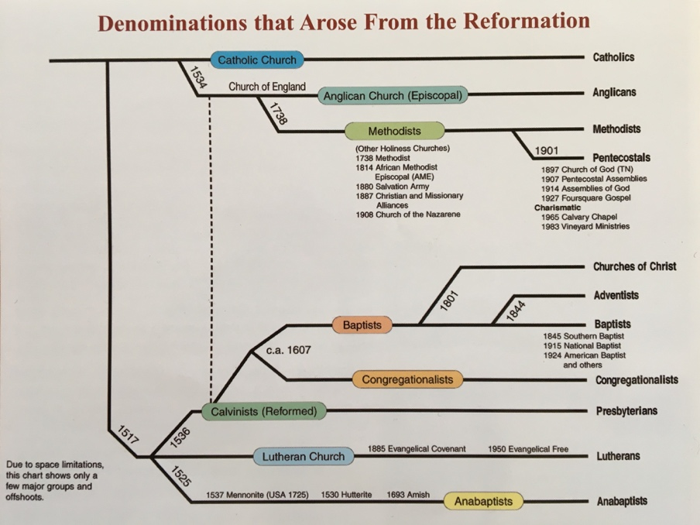
- To understand the influence of a Presbyterian confession written in 1646 on our own church today, it would be helpful to know where our denomination falls with respect to Presbyterianism. Can you show me where our denomination fits in the chart below?

Pastoral Interview Questions - Specific Theological Topics
Each student in our class has written one question based on a doctrine of interest to him/her. Ask your pastor all of the following questions. The last question is specific to your analysis of your church’s statement of faith/confession – make sure you have done this research and provided that to your pastor in advance of your interview. Take good notes (or ask your pastor if you can record the interview!) as you will be sharing your findings with the class!
- In studying the Westminster Confession of Faith, we have heard from a Roman Catholic priest, a Lutheran minister, and a Presbyterian pastor on their views of the Lord’s Supper (transubstantiation, consubstantiation, and “real presence,” respectively).
The Confession states that “In this sacrament, [The Lord’s Supper,] Christ is not offered up to his Father; nor any real sacrifice made at all, for remission of sins of the quick or the dead; but only a commemoration of that one offering up of himself, by himself, upon the cross, once for all…” (WCF 29.2)
In addition, it says that “The outward elements in this sacrament…have such relation to him crucified, as that, truly, yet sacramentally only, they are sometimes called by the name of the things they represent, to wit, the body and blood of Christ; albeit, in substance and nature, they still remain truly and only bread and wine, as they were before.” (WCF 29.5) [Zach]
        - What do you believe about the presence of Christ in the Lord’s supper, and how do you see this view supported in Scripture?
        - How does this view impact how your church celebrates the Lord’s Supper?
        - How does your understanding of communion affect you personally?
- With regards to initial salvation, the Confession (15.6) seems to order repentance and faith alongside one another, with the enablement of obedience to God through the Holy Spirit following salvation. But passages like Hebrews 6:1 place repentance before faith, and still others seem to only cite faith as that which saves you (John 3:16, Romans 10:9, Ephesians 2:8-9). [Corban]
How does our church address this, and what do we believe about the order of repentance, faith, and obedience to God in salvation?
- The confession, in its chapter on justification, states that those whom God effectually calls he also justifies by "...pardoning their sins and by accounting and accepting their persons as righteous; not for anything wrought in them, or done by them, but for Christ's sake alone" (WCF 11.1).
It continues later in the chapter, "They [the justified] can never fall from a state of justification, yet they may, by their sins, fall under God's fatherly displeasure, and not have the light of his countenance restored into them, until they humble themselves, confess their sins, beg pardon, and renew their faith in repentance" (WCF 11.5).
It appears from the confession that the justified man cannot lose his justification, but some portions of scripture seem to admit the possibility that a person can walk away from, or lose, his faith/justification. For example, 1 Tim 4:12 states "...some will depart from the faith by devoting themselves to deceitful spirits and teachings of demons" and Luke 8:13 states "...but these have no root; they believe it for a while and in time of testing fall away." [Paige]
  - Do you believe that a Christian can lose his justification/faith?
  - If so, how does that happen and how can it be avoided?
- The WCF states that "man, by his fall into a state of sin, hath wholly lost all ability of will to any spiritual good accompanying salvation" (CH 9, section 3). [Andrew]
  - Do you think man plays any part in his own salvation?
  - If so, how does it compare to that of the Trinity?
  - What are your “go to” scriptures for this topic?
- The WCF (CH 14, section 2) states, “But the principal acts of saving faith are accepting, receiving and resting upon Christ alone for justification, sanctification, and eternal life, by virtue of the covenant of grace.”
However, James 2:17 and Revelation 20:12 seem to be stating that we NEED works in order to be saved. [Tia]
  - Are we justified by our faith in Christ or do we rely on our deeds to be saved?
  - What role, if any, do our works play in our salvation?
- Chapter 6 section 1 of WCF states “Our first parents, being seduced by the subtilty and temptations of Satan, sinned, in eating the forbidden fruit. This their sin, God was pleased, according to His wise and Holy counsel, to permit, having purposed to order it to His own Glory.” [Karyn]
  - Why did God allow the human race to fall into sin?
  - The last part of the quote above seems to imply that sin ultimately brings glory to God. What are your thoughts on this and what scripture would you point to?
- Our church’s Statement of Faith seems to differ from the Westminster Confession in a number of ways. I’ve noted two below and would love to discuss them with you during our interview.
        - Describe difference number 1 here –ask a question..
        - Describe difference number 2 here –ask a question..

Background

Use this (but don’t feel limited to it) to help your pastor understand the nature and context of your studies, and how WCF fits into it:
  - This year’s Omni III focuses on the history, theology, and literature of the Protestant Reformation to present time.
  - Your study of the Westminster Confession falls into your “Doctrine & Theology III” course – here’s part of the course description:
“This course covers the development of the church, in form, function, and theology from the Protestant Reformation to the Post-modern ideas of present day. Students will be guided in logical analysis of their reading, extensive discussion and communication of ideas, and organization and composition, comparing and contrasting the texts with the philosophies of today's culture and analyzing both through the lens of Biblical truths.
Through extensive reading and class discussion, students will learn to identify the seeds of destructive theology, and will be challenged through the prophet Daniel and early church fathers. Liberalism, Modernism and Post-modernism have penetrated our culture deceptively. Students will engage with the culture as they work through identifying man's wisdom falling short.”
  - So far this year you have read: The Westminster Confession of Faith, The Pilgrim’s Progress, Foxes Book of Martyrs, and Frankenstein. This quarter, you will be launching into Pride & Prejudice, Of Plymouth Plantation, The Social Contract, and the autobiographies of Benjamin Franklin and Charles Finney.

